**CREATE AND CONFIGURE IBM CLOUD SERVICES**

### Create Node-RED Service

|  |  |
| --- | --- |
| **Date** | 05 November 2022 |
| **Team ID** | PNT2022TMID27179 |
| **Project ID** | Smart farmer -IOT enabled smart farming application |

### 

### *To CREATE AND CONFIGURE IBM CLOUD SERVICES to Create Node-RED Service*

### *IBM CLOUD LOGIN*

### 

***CREATE IBM CLOUD NODE-RED SERVICE***

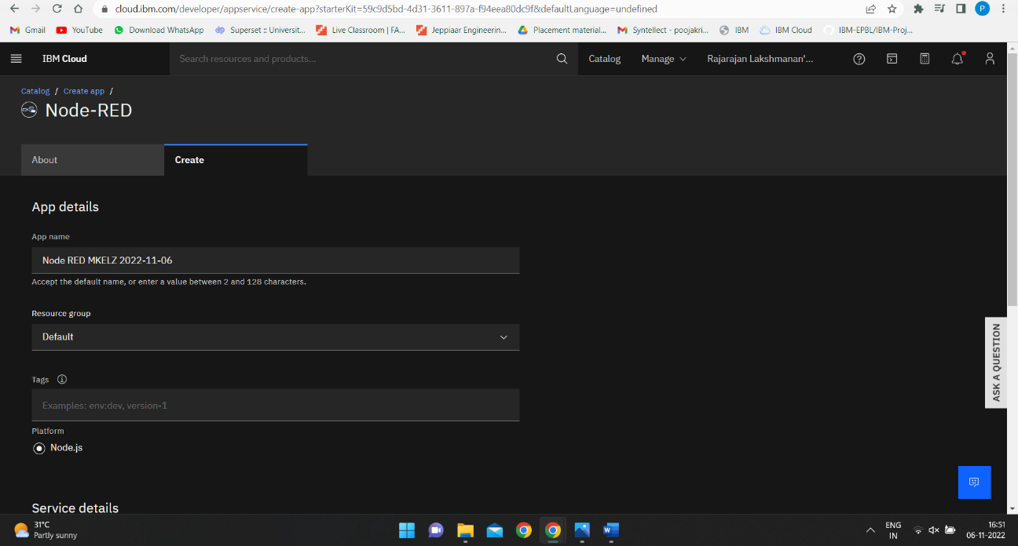

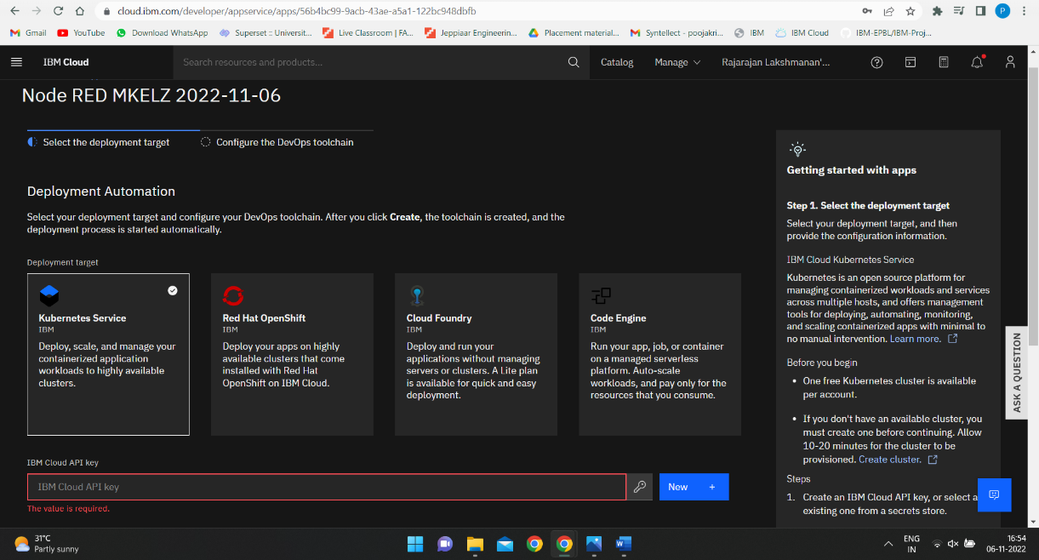

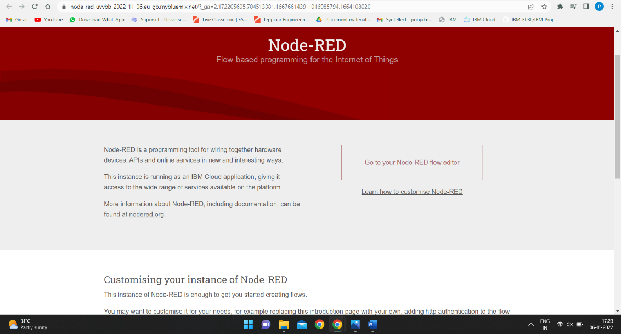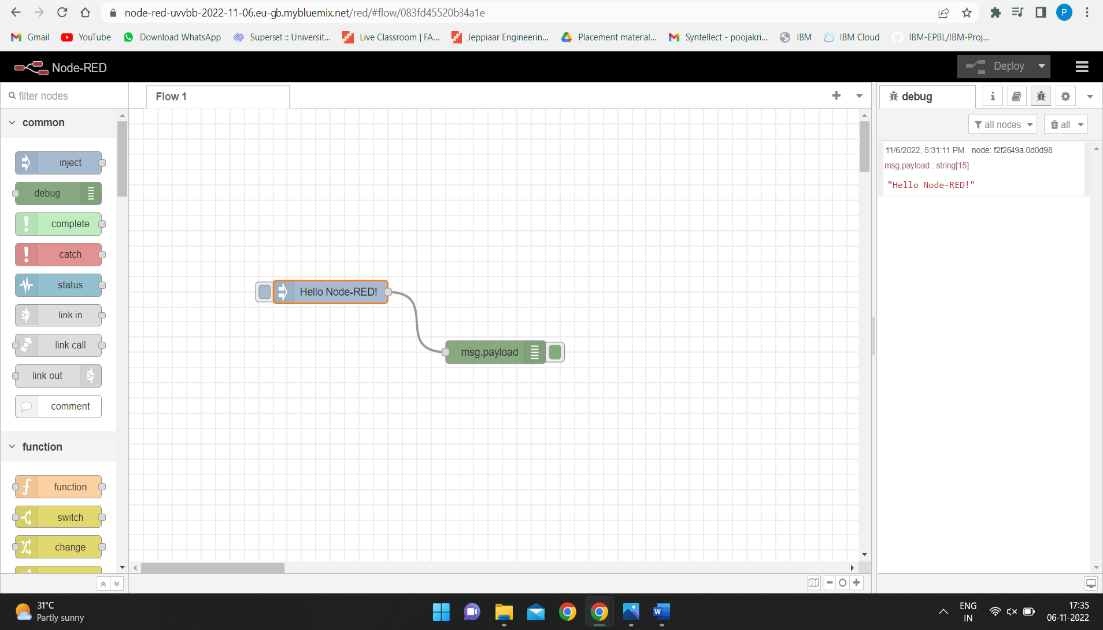

***IBM NODE RED***